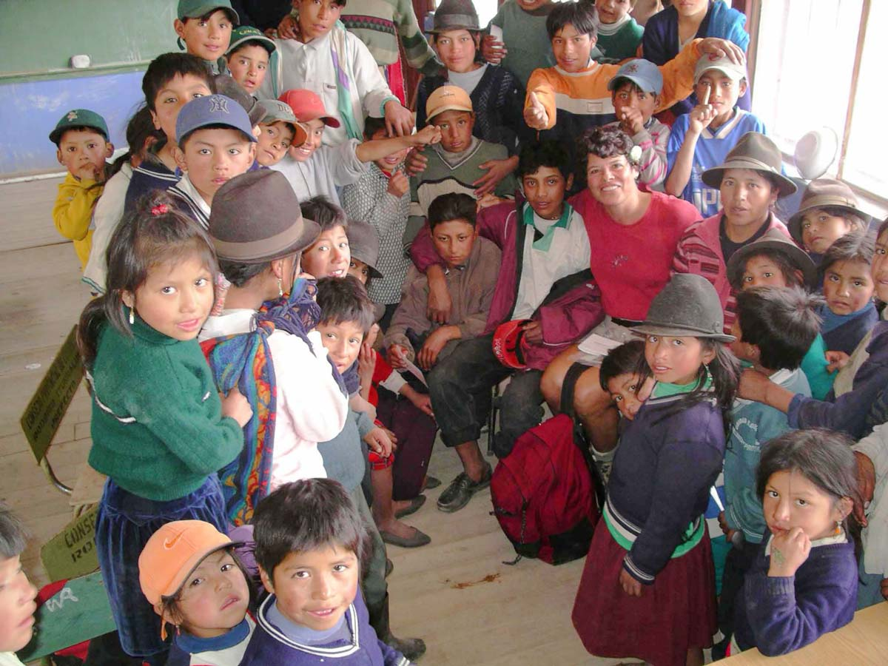

Centro Educativo La Minga, Inc.
-tax-deductible, non-profit 501(c)3 corp.

October 23, 2010
Dear Granby Rotarians,

We are very grateful for your loyal support since 2007 for our education and water projects in the Andes of Ecuador. Since 2007, our secondary school has grown from 3 grades to 6 grades. Plus, 9 members of our first class (from 2004) who just graduated in July ;-) are now attending university!

Our contributions have really been impacted by the economy --- we almost didn’t open school this year. Engineers Without Borders (EWB) have the design ready to complete the last 10% of the potable water project, but don’t have the funds ready. Reminder: we don’t pay for labor as the Quechua do mingas (“barn raising” type of labor); we only need to provide the materials.

Sustainability.
Education: Starting in January, 2011, the local Ecuador government has promised to start paying for one of the six secondary teachers and will add a teacher to their payroll each calendar year thereafter. Currently the government is paying for the kindergarten monitors, pre-school teacher, elementary teacher, and an English teacher.
Potable & Irrigation: There is a Board of Directors for each. EWB has been working with them including training plumbers and establishing a reserve account to use for replacement parts.
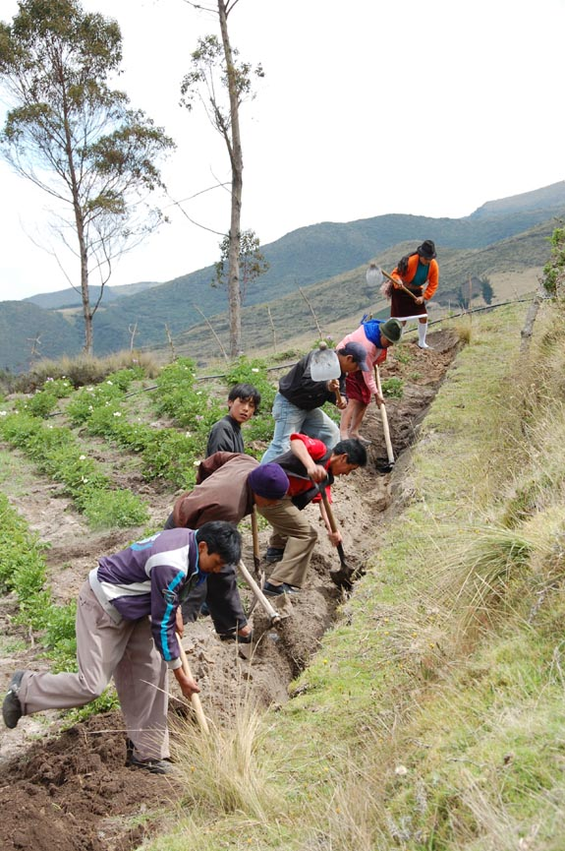
We would appreciate any financial assistance*. For example:
Monthly cost for each of our “university students” is $250;
Monthly teacher payroll is $1,200;
To complete the potable system, EWB estimates $15,000.

Thank you so much for your consideration!

Abracitos – little hugs ;-)

pam gilbert
CEO/Founder of Centro Educativo La Minga, Inc.
p. o. box 1877
granby, CO 80446
www.escuelaminga.org
gilbertp0012@yahoo.com
303-543-8223
A MINGA in action! Note: all secondary students.

*100% of your donation is applied to the project – none is applied to salary, etc.
P.S.
If you would like to see how your money is being spent, please join me on my next trip - ~ April, 2011.

